# Human Machine Interface

The FT NavVision *Human Machine Interface* (HMI) displays the current state of any physical device (I/O) on one or more monitor screen(s) by color, animation or values.

Moreover, when an undesirable state of a device is detected the operator will be notified by means of an audible and/or visible alarm signal. Messages concerning the alarm are added to the FT NavVision list of active or unacknowledged alarms (*Alarm Page*). This list can be displayed by clicking the Imtech logo in the center of the taskbar.

The HMI also supports remote platform control. Operators can control the platform (vessel) via the HMI.

## Taskbar

NavVision’s main User Interface (UI) element is the taskbar, positioned on top of each screen. The taskbar is home to the shortcuts to various settings, modules and mimics.

In addition, when an alarm is registered, the middle portion of the taskbar turns a bright red and shows the most recent unacknowledged alarm, the number of active alarms, and the total number of unacknowledged alarms. A single mouse click on this portion of the taskbar links to the extensive alarm viewer, showing the data for each active alarm such as time, alarm group, status and duration.

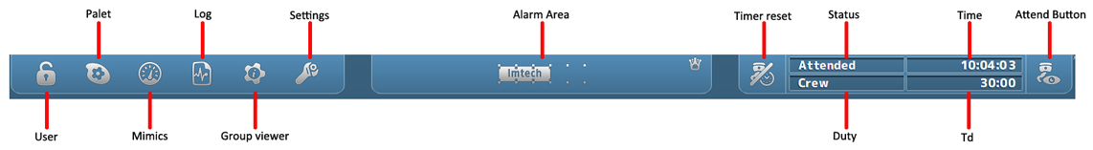

Figure 1‑1: NavVision taskbar

|  |  |
| --- | --- |
| **Takbar Icon** | **Explanation** |
| User | Setting of user and user rights |
| Palette | Setting of colors and day, dusk or night mode |
| Mimics | Selecting the mimics |
| Log | Show the log files |
| Group viewer | Show information on all I/O |
| Settings | Entry to all settings |
| Alarm Area | Click to show/hide alarm mimic |
| Timer Reset | Reset deadman timer, show active/inactive state |
| Status | Show status of attendance of the ER |
| Duty | Show person on duty |
| Time | Time |
| Td | Time dormant (for deadman timer) |
| Attend Button | Attend/unattended button for ER or Bridge |

Table 1: NavVision taskbar

### User rights

FT NavVisionhandles control rights by using log-in credentials (username and password), and assigning rights to these credentials. These rights limit access to the system's configuration, therefore ruling out any edits that may harm the system made by unauthorised crewmembers.

Users can be added, edited or removed. Adding, editing and removing users, together with assigning their rights, can only be done by an administrator, i.e. a top-level user.

For every profile made, permissions can be set. The system is delivered with three pre-configured user-profiles, namely:

1. *Administrator*: has all rights;
2. *Guest*: can only use the available viewers;
3. *Operator*: can only alter display mode and/or units.

Login is required upon system start-up. After start-up, users can log off and log in using the dedicated button on the taskbar. By clicking the button, the following window will appear:

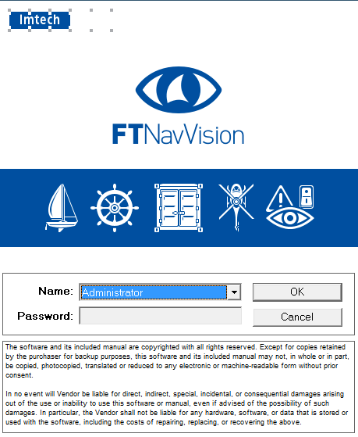

Figure 1‑2: User selection

By clicking the drop-down menu “Name”, you can choose which user you want to start. Provide the password if necessary and click “OK”.

### Palette

The palette is meant to give a quick selection to change the color settings of the screen. When you click the button, you’ll be presented with 4 choices (see Figure 1‑3).

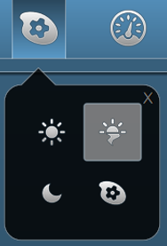

Figure 1‑3: Palette options

From left to right (beginning top left), there are three predefined buttons: Day, Dusk and Night. These choices give you the right colors and brightness for these specific periods of time. The last one is the palette selection tool. Using this, you can change the colors of the three presets to your liking.

* When you change the colors of a preset, be aware that there is no “Default” setting. It might be hard to get the colors back to their old state.*

### Mimics

When you click the mimic button, you’re presented with a grid of mimics available to you. It‘s possible that you have all the mimics as numbers so you have to choose the right number (see Figure 1‑4).

If you know the right number for the mimic you want to see, simply click on the corresponding icon.

Quite often, the only mimic icon that is presented is number one. This is the home mimic. From the home-mimic you can then navigate to other mimics.

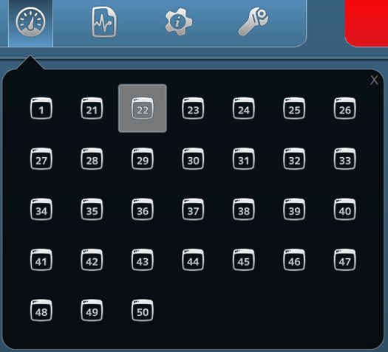

Figure 1‑4: Mimic menu

#### Mimics

The FT NavVision mimic presentation function provides schematic and graphical overviews of the vessel’s systems like navigation lights, electrical, piping and hydraulic overview.

The screens and mimics presentations are automatically updated with live data of the platform components illustrating components and/or system status.

Via these screens and mimic pages, the operator is able to monitor and control the vessel by using the trackball or touch-screen as a pointing device by selecting elements and their associated commands.

#### General

In general, we say that every page that represents a set of values, switches or any other representation of data is a mimic. The mimics within the system are all freely adjustable within the design stage. After the system is delivered, changes can be made by the NavVision engineers, on appointment. Small changes to the mimic can be made by a trained and skilled operator, who is granted some extra rights in the system. This trained crewmember will have the documentation, so we won’t discuss the changing of mimics in this manual.

#### Mimic examples

Although the mimics are freely adjustable, the main setup will be greatly alike on your screen. Imtech has defined some rules that the mimics have to live up to. This results in an overall recognizable style of mimics that gives it the modern and stylish look and feel.

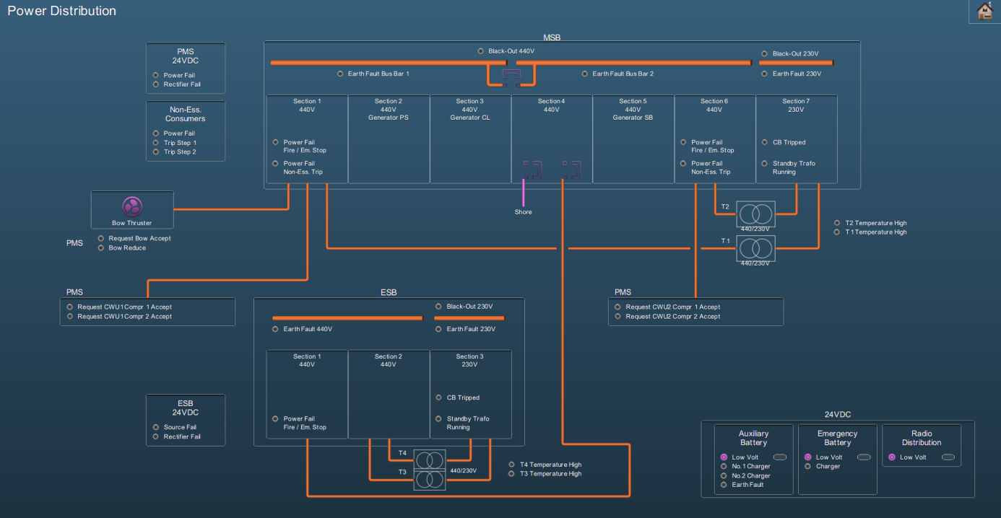

Figure 1‑5: Mimic example 1

#### Reading the mimic

Some installations contain a special *legend* mimic. This mimic explains the symbols, variations, colors etc. that you can find in your system’s mimics (see Figure 1‑6). If there is ever a doubt in what you observe on the mimic you are watching, please refer to this mimic.

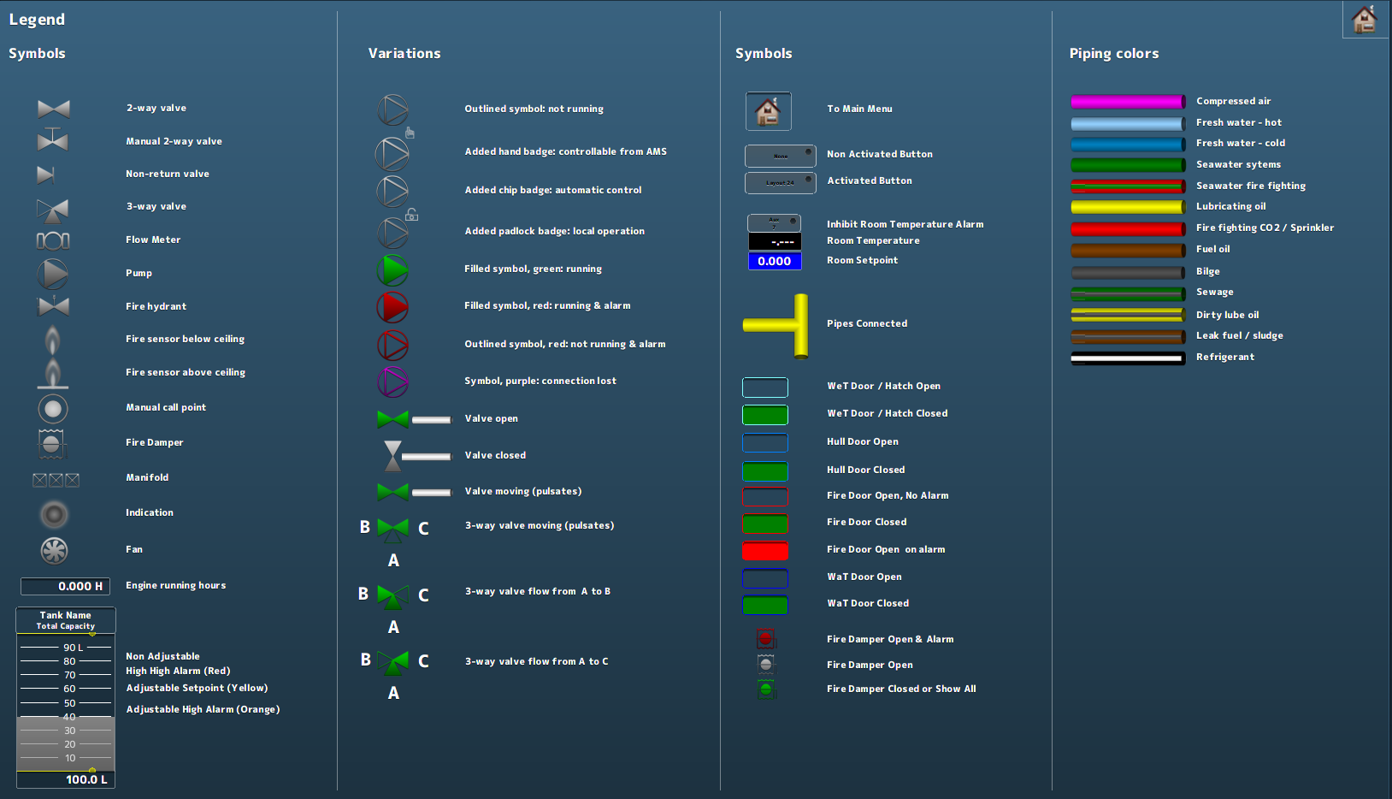

Figure 1‑6: Legend mimic

Other mimics can show a variety of information. There can be mimics for power distribution, tank volumes (see Figure 1‑7), fire alarms and many more. It is also possible that you have a combination of subjects on one mimic. Mimics are perfectly capable of displaying camera feeds or trend graphs.

As a special feature you can show the alarm list or the logbook on (part of) the mimic (see Figure 1‑8).

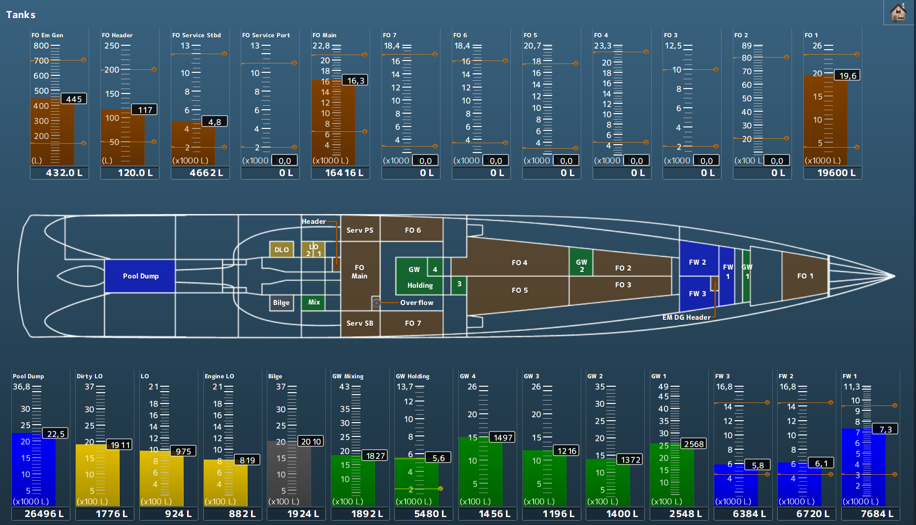

Figure 1‑7: Tank mimic

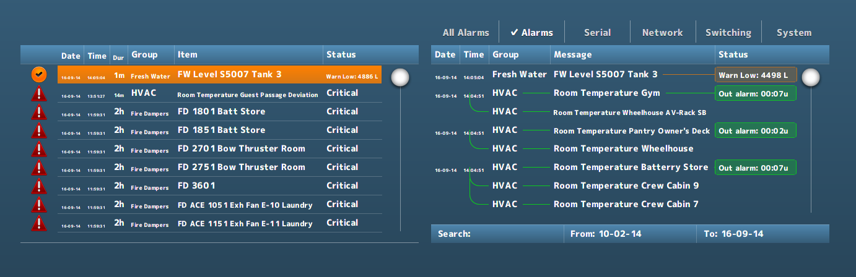

Figure 1‑8: Alarm list and logbook in mimic

*More extensive explanation on control in a mimic can be found in Annex 1 (See Chapter 6, page 47).*

### Logbook

During normal operation, all system events are registered chronologically. By clicking the *Logbook* button (see Figure 1‑1), these registered system events are displayed in a dedicated screen. It is also possible to show the logbook in any mimic (see Figure 1‑8).

#### Logbook groups

In order to separate various categories of information from each other, log entries are stored in various logging-groups. You can select them all or just a few of them, or even one if you need to focus on these entries. Just by selecting the category label at the top of the list, you filter the information you need (see Figure 1‑9).



Figure 1‑9: logging groups, all selected

|  |  |
| --- | --- |
| **Logging group** | **Explanation** |
| All Alarms | Alarms from all stations (even alarms you might not see on this station will be logged) |
| Alarms | All alarms from this station (all alarms that are visible on this station will be logged) |
| Serial | All serial information available on this station will be logged (initializing, finalizing and errors) |
| Network | All network information available on this station will be logged (Connecting, conn. Failed and errors) |
| Switching | All system, network and program switching |
| System | All process information and errors |

Table 2: Logging groups

#### Logbook appearance

All identical log entries that appear at the same time will be interconnected as shown in the following figure (see Figure 1‑10).

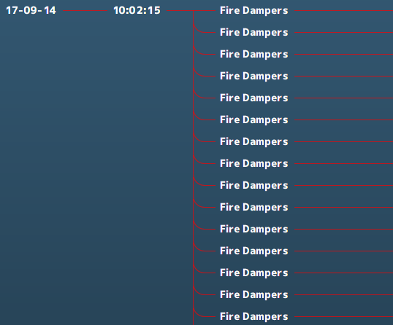

Figure 1‑10: interconnecting log appearance

#### Logbook status indication

All entries will have an explanatory status indication at the end of the entry line. This will give an indication about the reason that the indication is in the logbook (see Figure 1‑11).

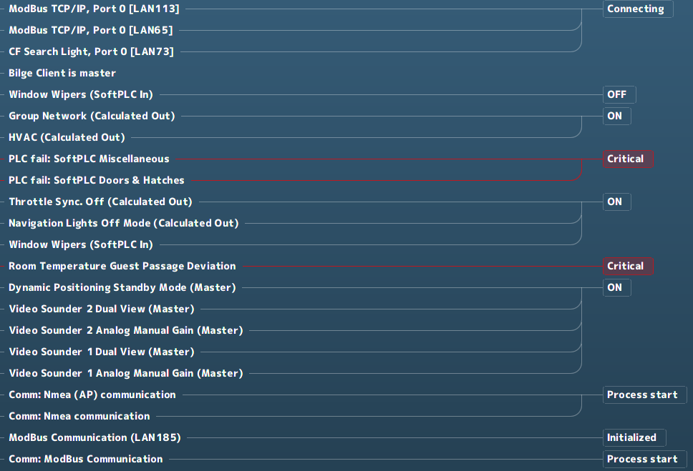

Figure 1‑11: Status indication log-entries

When logging alarms, this status indication will also be colored.

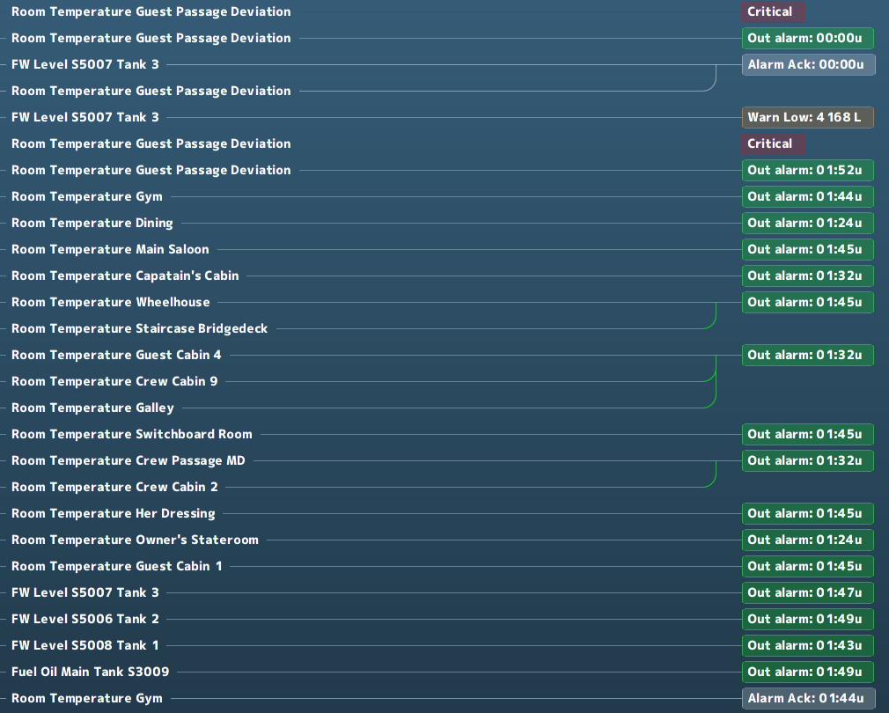

Figure 1‑12: Logging colors

|  |  |
| --- | --- |
| **Logging colors** | **Explanation** |
| Grey | Acknowledged |
| Green | Out of alarm or OK |
| Yellow | Caution |
| Orange | Warning |
| Red | Critical, Slowdown and Shutdown |

Table 3: Logbook colors

#### Logbook search bar and buttons

At the bottom of the logbook, you will find a search bar and a few buttons (see Figure 1‑13). In the search bar, you can click and type the name of the listing you are looking for. After hitting *Enter* the listing is shown, if available.



Figure 1‑13: Logbook search bar and buttons

If you click on the “From:” or “To:” on the search bar, a new window will appear (see Figure 1‑14). This window is a fully working calendar from which you can choose a “From” or “To” date. After you have entered the date and pressed the checkmark, the entries that occurred in the entered timeframe are shown.

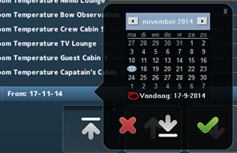

Figure 1‑14: Search calendar



Figure 1‑15: Print button

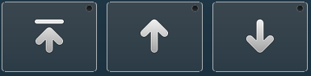

Figure 1‑16: Up- down buttons

If you click the *Print* button, you can print the logbook (if a printer is available). With the *Up* & *Down* buttons you can scroll to the top, up or down.

### Group viewer

The *Group Viewer* is the place within FT NavVision that holds the necessary information about all connected I/O. In this window, you can find a descriptive line for all the sensors with their connections and dependencies (see Figure 1‑17).

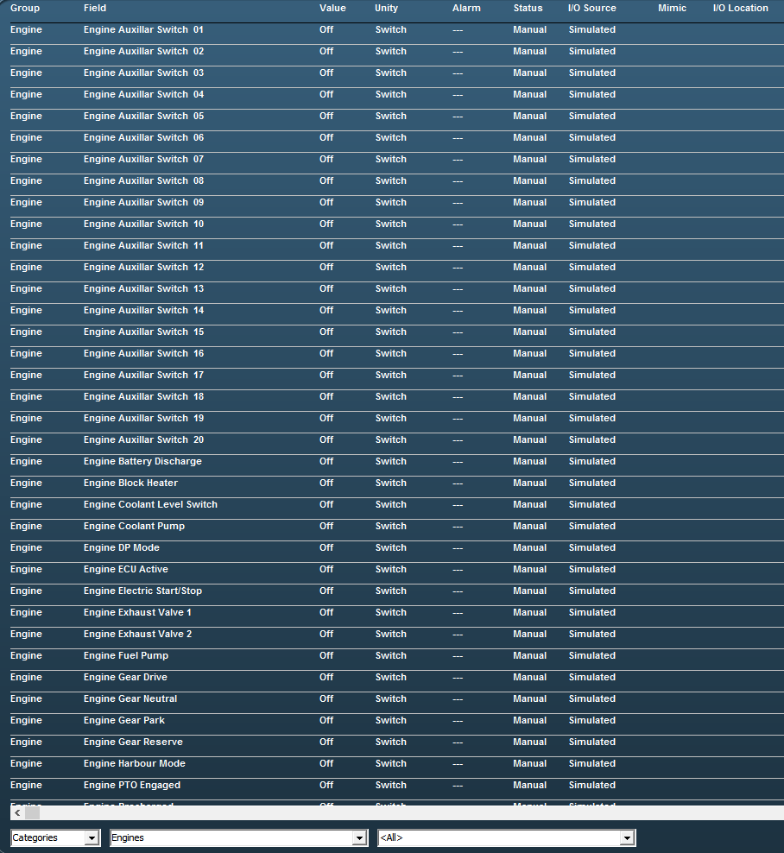

Figure 1‑17: Group viewer

There are various columns that each list a specific piece of metadata of an I/O point in clear language or digits and colors.

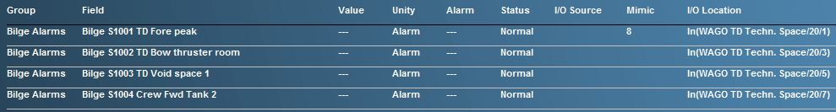

Figure 1‑18: Group Viewer columns

|  |  |
| --- | --- |
| **Column** | **Explanation** |
| Group | The alarm group the I/O point belongs to |
| Field | The item name of the I/O point (FT NavVision ID-tag) |
| Value | Actual value of the I/O point |
| Unity | The Unity of the I/O point |
| Alarm | Shows if the I/O point is in alarm and the value of the alarm |
| Status | Status of the I/O point |
| I/O Source | The source (interface) the I/O point comes from |
| Mimic | The mimic(s) the I/O point value is present |
| I/O Location | The location where you can find the I/O point physically |

Table 4: Group Viewer columns

#### The search bar

Using the search bar, you can reduce the amount of searchable data to a specified group. This way it is easier to pinpoint the faulty I/O point you are looking for (see Figure 1‑19).



Figure 1‑19: Search bar

In the first drop-down menu, you can choose between *Categories* and *Alarm Groups* in which you change between the standard arrangement of categories as set in FT NavVision or the division in alarm groups.

When choosing for *Alarm Groups,* you have the choice to narrow the selection down even further to the specific alarm group that you are looking for (see Figure 1‑20).

When you choose for the *Categories*, you can narrow it down to the group and even subgroup for that particular I/O point (see Figure 1‑21 and Figure 1‑22).

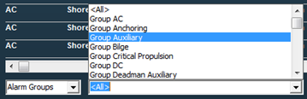

Figure 1‑20: Alarm groups

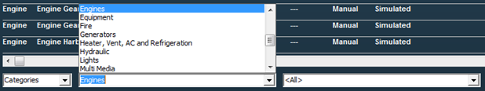

Figure 1‑21: Categories group

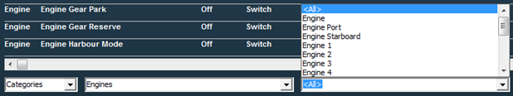

Figure 1‑22: Categories subgroup

If there is an I/O point currently in alarm status, it will give information on the fact that it is in alarm (red) and what its status is (see Figure 1‑23). Also the mimic it is presented on and the I/O location can be read from the group viewer (see Figure 1‑24).



Figure 1‑23: Group viewer in alarm



Figure 1‑24: Group viewer mimic and I/O location

### Settings

The settings Icon is not applicable to the operator. There is nothing in this submenu that may be adjusted by an operator.

### Alarm Mimic

The *alarm mimic* is the central place where all relevant alarms are shown in clear and unambiguous language and coloring. The smaller *Alarm area* in the taskbar will always be available and visible. Here, each alarm will be shown immediately. When you click the area, the larger Alarm mimic is shown (see Figure 1‑25).

*The Alarm mimic will always be on top of all the other windows, so if you want to look at other mimics, you will need to close the alarm mimic first.*

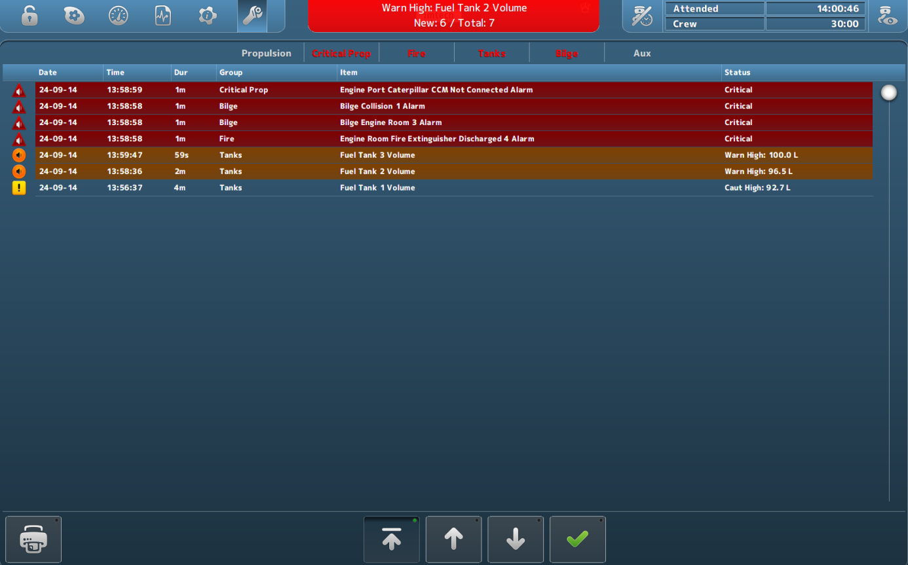

Figure 1‑25: Alarm mimic

Depending on which rights your station has, more or less buttons and/or alarm-information are shown.

The order will always be as follows:

* Critical alarms
* Warnings
* Cautions
* Time of appearance

So the latest *critical alarm* will always be on top. The latest *warning* will always be on top, after all *critical alarms.* Similarly, the latest *caution* will always be on top after all *critical alarms* and/or *warnings*.

#### Alarm icons

The alarm icons have distinctive colors and symbols, so you can see exactly what is going on with each alarm. A brief explanation of each icon is shown in the following table.

|  |  |
| --- | --- |
| **Icon** | **Explanation** |
|  | Critical alarm: Unacknowledged |
|  | Critical alarm: Silenced |
|  | Critical alarm: Acknowledge not allowed |
|  | Critical alarm: Acknowledged |
|  | Critical alarm: Rectified |
|  | Critical alarm: Transferred |
|  | Warning: Unacknowledged |
|  | Warning: Silenced |
|  | Warning: Acknowledge not allowed |
|  | Warning: Acknowledged |
|  | Warning: Rectified |
|  | Warning: Transferred |
|  | Caution: Unacknowledged |
|  | Caution: Silenced |
|  | Caution: Acknowledge not allowed |
|  | Caution: Acknowledged |
|  | Caution: Rectified |
|  | Caution: Transferred |

Table 5: Alarm Icons

The bottom of the alarm mimic houses buttons for printing and scrolling.



Figure 1‑26: Print button



Figure 1‑27: Up- down buttons

Upon clicking the *Print* button, you can print the alarm list (if a printer is available). With the *Up/Down* buttons you can scroll up, down or jump to the top of the list.

*The rest of the Alarm mimic will be explained in Chapter 2 (Duty Alarm System) and in chapter 0 (Personnel Alarm).*